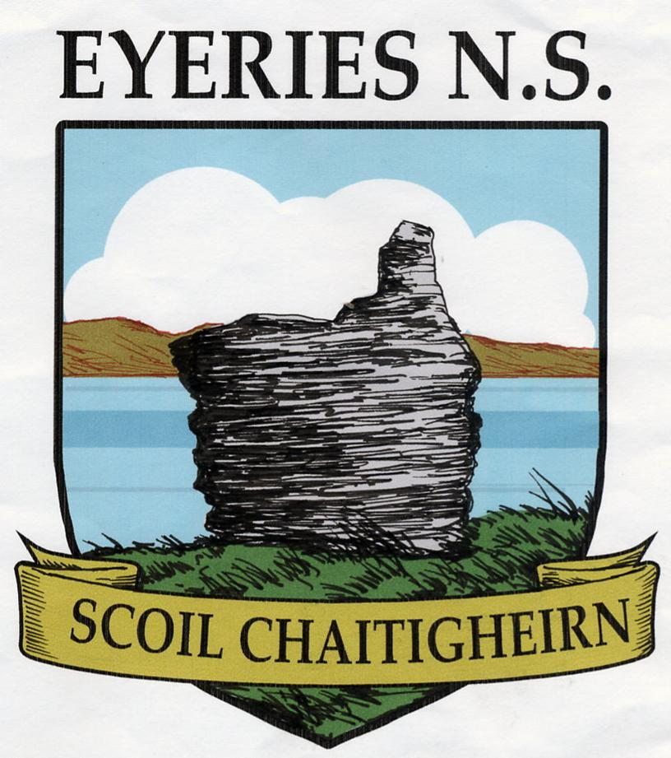
Scoil Chaitigheirn
Eyeries
Beara
Co Cork
T: 027-74053 |  | Principal: Micheál Lane  Deputy: Fergus Carey
E.mail: eyeriesns@gmail.com
APPLICATION FOR ADMISSION OF NEW PUPILS
Name of Child
Date of Birth
Father’s Name
Mother’s Name & Maiden Name
Home Address

Home Tel No |  |  |  | Work Tel No |  |  |  |  | Mobile Tel No
Religious Denomination
Date & Place of Baptism (If applicable)
Father’s Occupation
Mother’s Occupation
Previous School(s) Attended (Give school name(s) and classes attended)
Do you give permission to take your child straight to hospital in case of serious illness or accident?
____________________________________________________________________________________
Do you give permission for your child’s image to be used by the school e.g. school website, newpaper, DVD etc?
_____________________________________________________________________________________
Do you give permission to the SEN teachers to withdraw your child in a small group for group tuition e.g. small maths groups, computers, SPHE, drama etc?
Does any legal order under Family Law exist that the school should know about?

Medical Card No or
SW Entitlement
PPS No
Have you attached the following?
Birth Certificate
Baptismal Certificate
Emergency Contact/Medical/Health Information Form
Assessment(s) – [Speech & Language, O/T, Physiotherapy…]
YEAR 2021-2022

We have read and agree to the ‘Code of Discipline’ in Scoil Chaitigheirn.
We will co-operate with the staff and support the ethos of the school
Signed

