Green Day by Anna
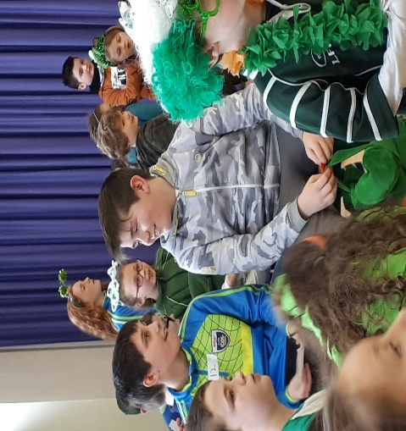

On the 15th of March, we celebrated Green Day. Everyone came to school dressed in something green. We assembled in the hall for a quiz organized and run by Mr. Lane and his very able 6th class. Table 7 won! The winners were Ronan McCarthy, Taylor Cody, Shane McCarthy, Darragh 0’ Sullivan and Darragh Hartnett. We all had great fun!
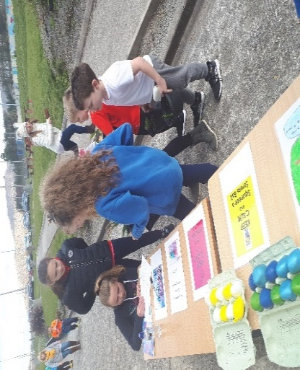
Junior Entrepreneurs by Mary Rose
We started our project in October last year. Quinlan Steele came to talk to us about being an entrepreneur. He gave us lots of advice and information. We had many ideas, but in the end we decided to go with Nina and Nichola’s idea of the stressball. We had lots of fun making, designing and selling them and showcased them on Friday April5th at the Bulb Sale. We made a profit of €10 each at the end of the project.
Bulb Sale
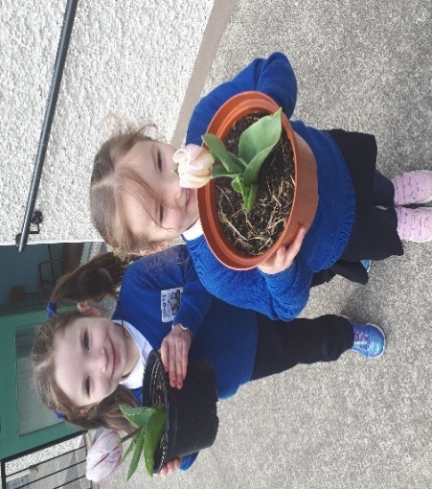
In December, the Parents’ Association organised Connie Downey to come to the school to plant bulbs with all the children. We had great fun getting mucky in the compost! We watch impatiently for the bulbs to grow and finally had our yearly bulb sale on April 5th. Hannah from the PA came to help us sell one bulb for €3 or 2 for €5. It was very successful and all the money went to the Parents’ Association. Thank you to all who bought our beautiful bulbs!
Supergran!
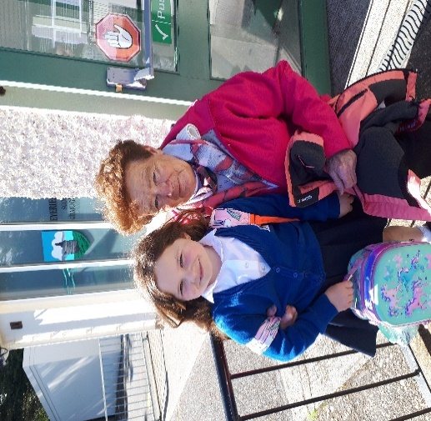
It’s not too often a pupil can say their great-grandmother comes to collect them from school, but that’s what we have here! Rosanne Harrington regularly skips down the steps to collect her great-granddaughter Riley Minihane. I don’t know what Roseanne’s secret is, but we are hoping she will share it soon, as it’s younger and more sprightly she’s getting by the day! Maith thú Roseanne!

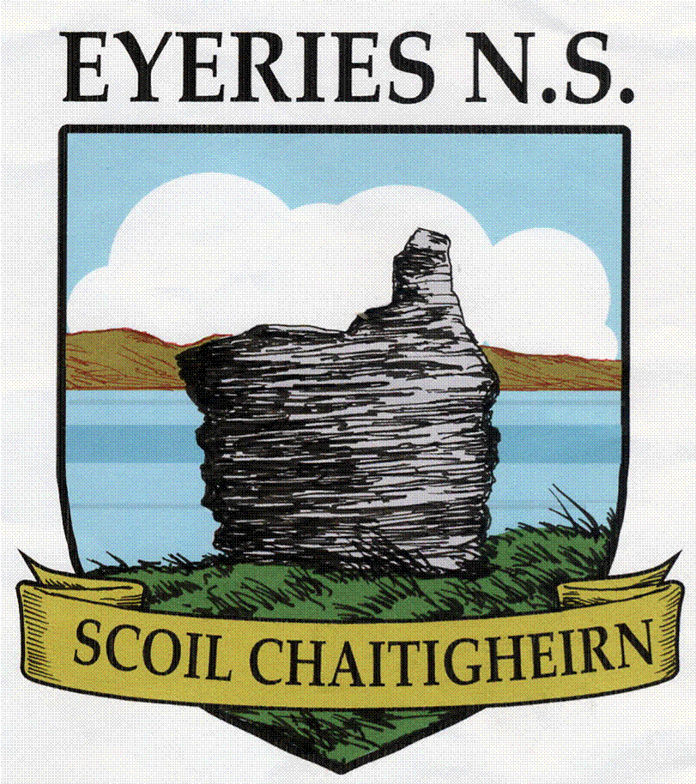
Easter
Newsletter 2019

Dear Parent(s)/Guardian(s),
I hope you and your family enjoy reading our Easter 2019 edition of the school’s newsletter. I wish to thank the 6th class students for chronicling the activities that our students have participated in over the past three months.
I want to acknowledge the enormous work done by our Board of Management and Parents’ Association during term two. I would like to thank you, the parents for your interest and ongoing support of Scoil Chaitigheirn.
Kindly note that you can contact the school office - ph. 027 74053 - on Mondays and Wednesdays between 9:00 am and 12 noon or Fridays between 9:00am and 11:00 am. The school will keep you briefed per text of the various events and activities during term three.
On behalf of the Board of Management and all the Staff, I wish you and your family a happy and safe Easter holiday.
Togha Sláinte,
Jimmy Murphy
________________________________________________________________________________________
Operation Transformation by Lukas
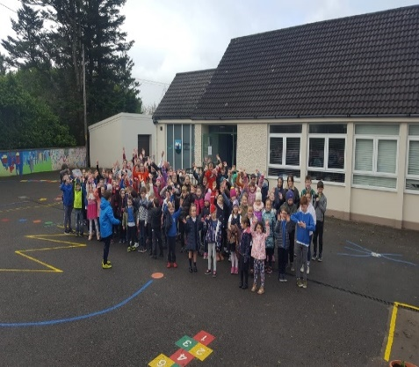
In January, we took part in Operation Transformation’s ‘walk a mile’. On Mondays and Fridays, the school emptied at 12 o’ clock and we did 8 laps of the school. One lap was measured at 100m, so we did 8 laps, which was 800m or a mile. There were lots of happy faces and many students learned very fast walking, as we couldn’t run! We hope it will continue next year!
World Book Day by Maeve
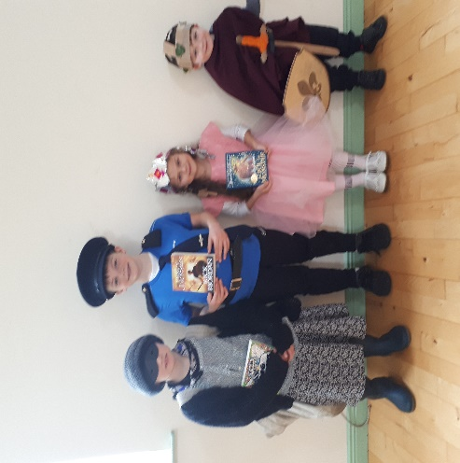
On March 8th, we had World Book Day! Everyone dressed up as a character from a book. We had some very creative costumes and there were some amazing and clever costumes. One pupil from each class received a prize of a book for the best dressed. See the prize-winners pictured here. Even some of the teachers dressed up! We had a brilliant day!

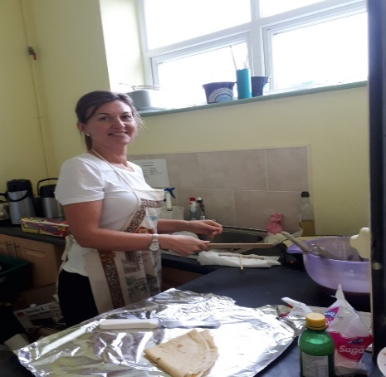
Pancake Tuesday
Thank you so much to Veronica McCarthy and all in 6th class, who spent the day cooking up a storm on Pancake Tuesday. Each child and teacher got a pancake with their choice of topping delivered to the classroom. All dietary requirements were catered for too, which was wonderful! Although, some of us think the gluten and dairy-free pancakes were much bigger! Míle buíochas!
Communion Preparations
Preparations are well underway with our Second Class, who will celebrate the First Holy Communion on May 18th in St. Kentigern’s Church, Eyeries. They made their First Confession on
Wednesday, April 3r. They did a wonderful job of it and were well prepared by their teacher, Ms Aisling Crowley.
Dancing with Hannah and Grandparents’ Day by Erica
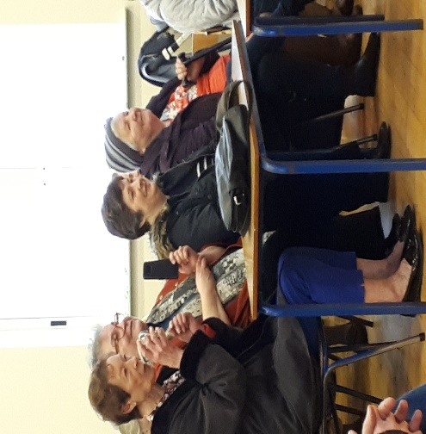
Funded by the Parents’ Association, each class did dancing with Hannah every Friday for 6 weeks. On the first of March, we celebrated Grandparents’ Day and entertained them all with our dances we had prepared with Hannah. Each class did their dance, while the parents and grandparents watched and had tea and biscuits. Afterwards, we all had a chat with our families. We really enjoyed the dancing and putting on a show
Beara Schools Quiz
Congratulations to our winners of the Beara Schools Quiz, which took place in Scoil an Chroí Ró Naofa, Castletownbere on April 11th. The quiz was intense and the competition was tough, but our Senior team won by 1 point!
Pearl Mussel Project by Aisling
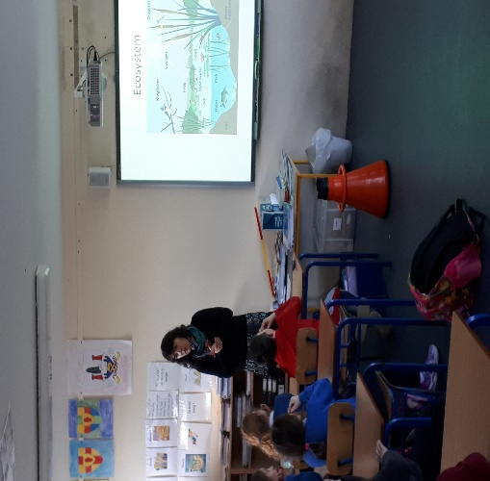
The biologists involved in the Pearl Mussel Project came to the school to explain to the senior classes how important this project is. On Friday, March 29th, 6th class were invited by Minister for Agriculture Michael Creed to Glenbeg, Ardgroom for the official opening of the project. The artwork completed 5th and 6th classes was displayed for all to see! We were treated to good food and lots of speeches, but really enjoyed our trip!

Music with Peggy
Music lessons continue with Peggy every Thursday, courtesy of the Parents’ Association.
Garda Brigid Hartnett by Alanna
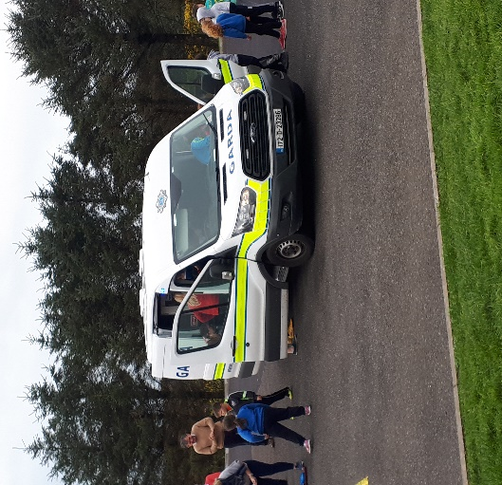
On Thursday, February 21st, Garda Brigid Hartnett came to see 1st to 6th classes. She spoke to us all in the hall about road and internet safety. After the talk, she brought us all to the basketball court to see her Garda patrol van a.k.a. ’The Paddy Wagon’! We climbed through every section and some of us even got locked into the cell at the back! We had sirens blaring and lights flashing too!
Community Games by Mark
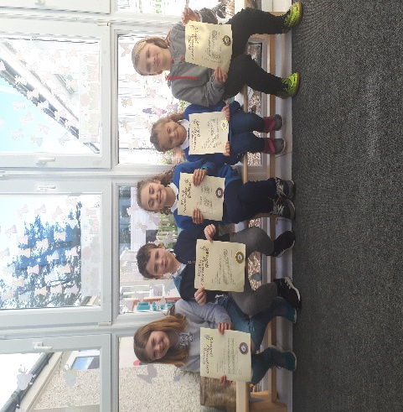
We had many winners in a variety of competitions, including drawing and handwriting. Congratulations to our winners PATRYCJA, Farrah, Darragh H., Abby S, Evan, Izabela, Nichola, Seán D., and Lukas. They have shown what wonderful talent we have in our school! Best of luck to you all at the next stage of the competition!
Easter eggs with Sue
On April 11th, Sue Booth-Forbes returned once again to die eggs with 3rd and 4th classes. They had spent the previous evening very creatively, making Easter baskets for their beautiful eggs. This is Sue’s 20th year doing this lovely activity with pupils in our school and we would like to thank her for all her time and commitment to us. Mile buíochas Sue!
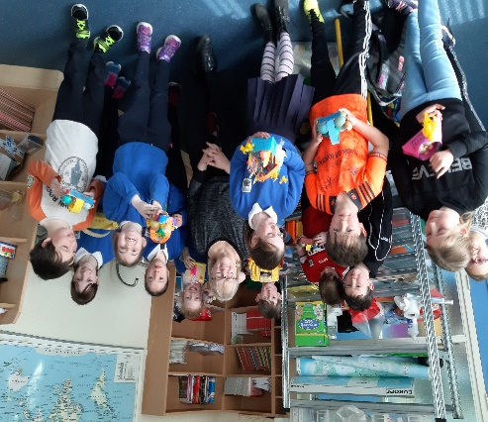
Sciath na Scol by Chloe
The boys and girls teams have been training hard each lunchtime for their matches after Easter. Mr. Murphy and Mr. Lane have been coaching them well and they are well prepared. Go raibh míle maith agaibh a mhúinteoirí as ucht bhúr gcuid ama agus fuinnimhe!
Swimming Lessons
Swimming Lessons will commence after the Easter holidays at The Water School in Kealkil. Details will be announced after the break.
School Tours
Preparations are well under way and details will follow after the break!

