Visit from Bishop Ray Browne by Mark Power
Bishop Ray came on June 18th, to meet all the teachers and pupils, but particularly the children who will make their Confirmation next year. Mr. Lane prepared a lovely prayer service with the children in 6th class and we sang some hymns. He spoke to all of us about God, the beautiful world we live in and how we need to look after it.
1st-6th Classes School Tour to Eclipse by Timothy
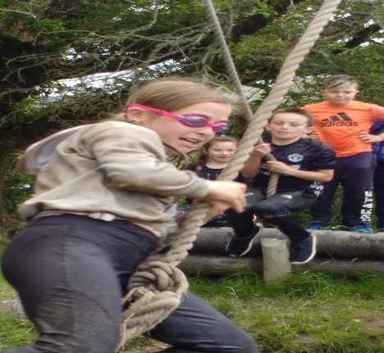
On June 17th, two busloads of us headed off to the Eclipse Centre in Blackwater for a day filled with fantastic activities. Each classroom went in their own group and we had a brilliant time at each of the activities including a mud run! We all returned home a little muddy, a little tired, but very happy after our great day out!
Plaque Unveiling by Anna
On the 17th of May, the whole school gathered outside in the Infant yard for the unveiling of a plaque dedicated to Donal Harrington Causkey, former chairperson of the Board of Management of Scoil Chaitigheirn for many years. All Donal’s family were there to see Jay, his wife, cut the ribbon. The plaque is on the outer wall of the Sensory Room for all to see and remember Donal.
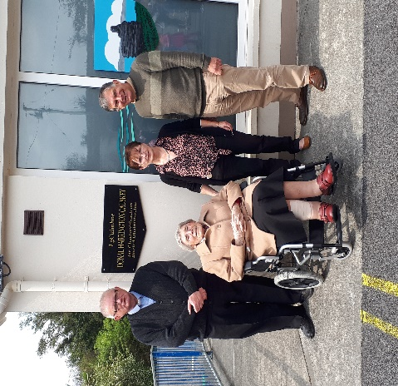
Swimming Lessons by Aisling
First to Fourth Classes have just finished their swimming lessons for this year at ‘The Water School’, in Kealkil. There are four different sections in the pool there, each for different levels of swimmers, so everyone gets to learn at their own level. On the last day, they get to go to the shop on their way home to buy some treats!
Cork City Sports by Alanna
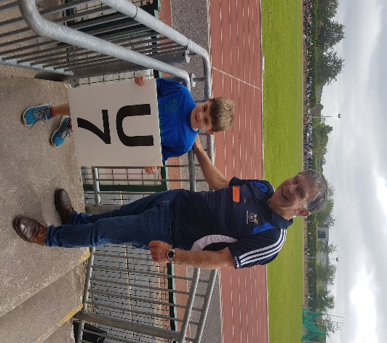
On the 30th of May, two children from each class went to CIT to represent the school at the Cork City Sports. The boys ran first this year and then the girls. The boys won three trophies, as did the girls and the girl’s relay team came second! James here was a real superstar, coming first in the U7 heats and getting through to the final. Maith thú James!

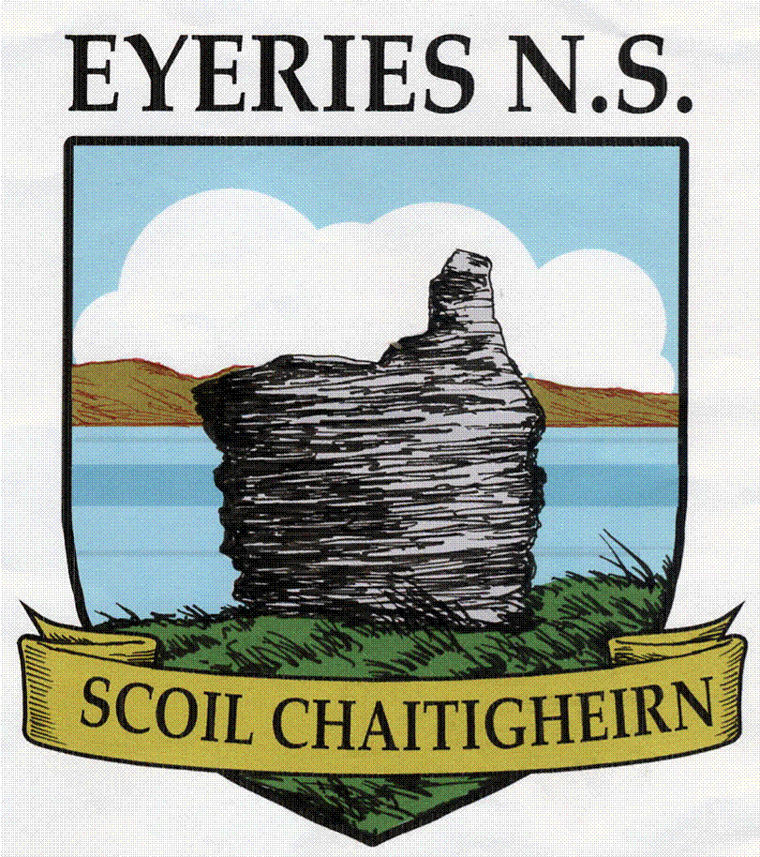
Summer
Newsletter 2019

________________________________________________________________________________________
Dear Parent(s)/Guardian(s),
Our final edition of the school newsletter for this school year, gives a flavour of the activities that the students participated in during the 3rd term. The children have been very busy, with school tours, swimming, athletics, football and BBQ. The staff in the school are very proud of their efforts. I want to congratulate all our students in particular our fourteen pupils in 6th class who recently celebrated their graduation mass with Fr. Danny Broderick in the presence of family, friends and staff. We wish them continued success in secondary school.
As you may be aware I have surpassed my ‘sell by date’ and am due to retire at the end of this term. I was most privileged to teach in such a lovely school and the years have passed too quickly. Scoil Chaitigheirn is a lovely school with a very supportive school community, in the most beautiful setting of Eyeries and we are very proud of our school. I would like to take this opportunity to thank our excellent Board of Management for their support, guidance and assistance to me and the staff. I wish to thank the Parents’ Association for all the ‘extras’ that the school was able to provide due to their commitment and endeavours. I want to thank you the parents for your interest in your children’s education and your unwavering support of the school. I wish continued success to all our pupils in life’s journey. I wish to extend my sincerest gratitude to all our staff for their dedication, professionalism, friendship and collegiality. I have made lifelong friends here. I sincerely wish you all a continued bright future.
May the Staff and I wish you all a happy and safe Summer.

Go mbeirimid go léir beo ag an am seo arís.

Togha Sláinte,
Jimmy Murphy
_______________________________________________________________________ Comhghairdeas Ms. O’ Shea!
Congratulations to Ms. O’ Shea, who received superb results in her Postgraduate Diploma in Special Educational Needs! We don’t know how she managed to teach all year and complete this, but our very own Superwoman has done it!
Slán Tamall, Ms. Crowley
Guímís araon gach rath ort Ms. Crowley agus tú ag tabhairt aghaidh ar shaol nua sa Nua-Shéalainn ar feadh bliana. Táimíd ag tnúth go mór le scéalta iontacha on leathsféar theas!

Infants’ School Tour by Thady
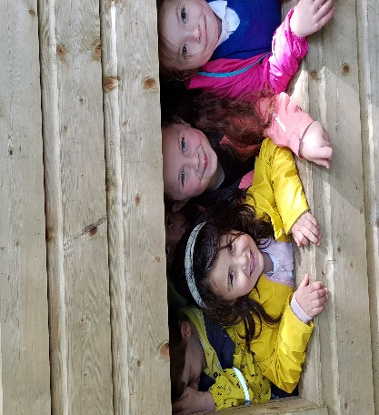
On the 5th of June, the Infants set off on Tommy’s bus to Kennedy’s Pet Farm. They had a wonderful time petting all the animals, rabbits, guinea pigs, kids and deer. The three little pigs, Connolly, Larry and Mo were very entertaining. The children played in the sand pit, swung out of climbing frames, gave the wobbly bridge a good shake and all returned home tired, but happy. What a great day they had!
Crazy Hair Day by Chloe
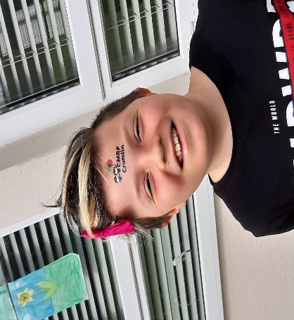
On Friday, May 24th, we had our Crazy Hair Day. We raised over €200 for Crumlin Children’s Hospital. There were so many different, crazy hairstyles. People twisted it, curled it, straightened it, dyed it, gelled it and put it standing on end! We all just went crazy! It was a really fun thing to do to raise money for charity.
Visit from the Fire Engine by Maeve C.
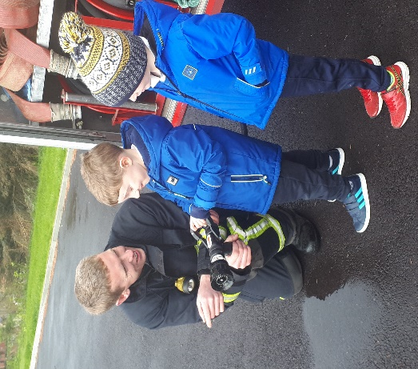
On the first of May, the Castletownbere Fire Brigade came to visit the school. Ian Murphy, Conor Twomey and Andrew O’ Sullivan spoke to us about fire safety in our homes. They taught us about checking our fire alarms and how to use fire blankets and fire extinguishers. They also showed us what happens when a tiny bit of water is poured onto burning oil. It was horrific! After the demonstration Andrew showed us how the hose works and we got to inspect the inside of the fire brigade. It was really interesting and great fun!
First Holy Communion by Mary Rose
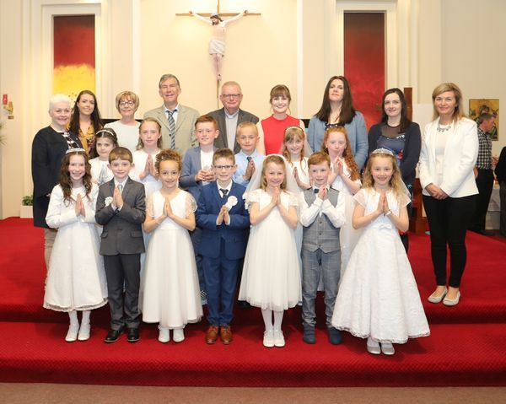
On the 18th of May, Second Class, together with two pupils from Urhan N.S. celebrated their First Holy Communion. Ms. Aisling Crowley did a wonderful job inpreparing the children and there were no nerves on the day, just smiles! Peggy Healy, our fantastic music maestro, led the choir and the school band, who were all outstanding. After mass, everyone gathered in the school for tea and cake, organised by the Parents’ Association. What a great day!

Graduation Mass by Nichola
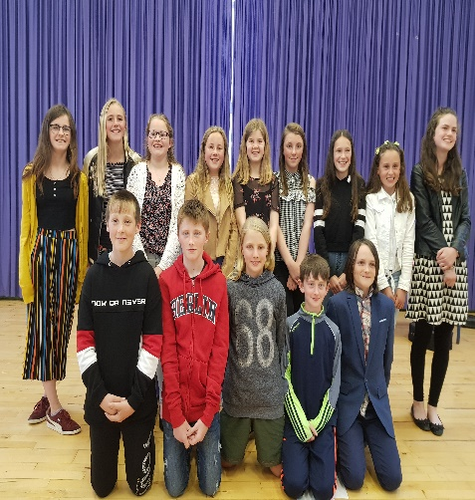
On the 13th of June, the sixth class of 2019 gathered in the school hall with their families, where Fr. Danny celebrated our Graduation Mass. We all had a part in the mass, which made it really special. After mass, we received a certificate, a memory box and a class photo. We presented gifts to Mr. Murphy, Mr. Lane and Ms. McCarthy to show our gratitude for all they did for us over the years. After that, we had tea and biscuits. It was a lovely evening and we had a great time!
Biodiversity Walk by Nina
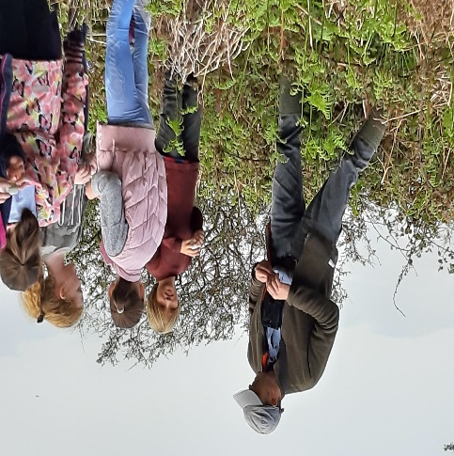
On the 17th of May, we visited Eoghan Daltun for our biodiversity walk. Third to Sixth Classes were very excited as we got on the bus at 11am to go to Bofficle Woods. There were clouds of midges, so Eoghan brought us to a different part of the woods and we collected a variety of bugs, leaves and small plants. We had great fun exploring and rooting through the undergrowth. Thanks Eoghan!
Sciath na Scol by Cameron
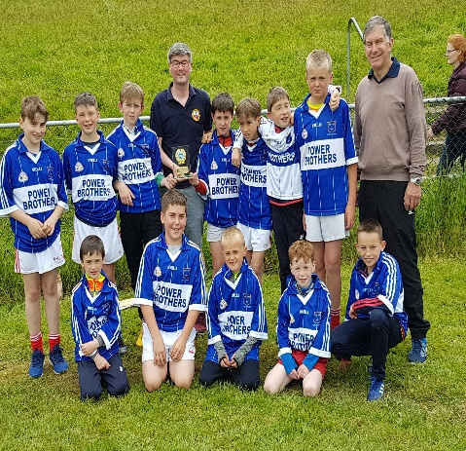
Mr. Murphy and Mr. Lane spent most lunch breaks training the boys and girls teams at the pitch all year. All our hard work paid off, as we did well in most of our matches. Unfortunately the girls didn’t make the final in Dunmanway this year, but the boys did! We played our best on the day, but were not successful. We had a great day out!
BBQ by Erica
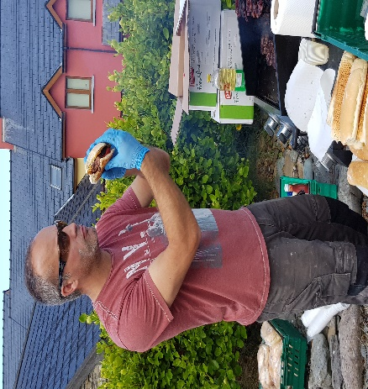
On the 18th of June, the whole school went down to Frank’s Corner, where we had a barbeque hosted by Colman and Declan O’ Sullivan. Each classroom took their turn and we were treated to hotdogs, burgers and juice. This was followed by a trip to the playground, where Mary O’ Sullivan treated us again with ice creams, before we returned to school. The sun shone once again for us this year! What a great day we had!

