First Holy Communion
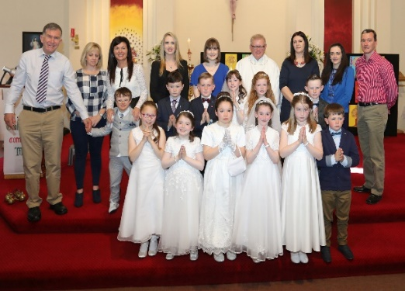
Second Class celebrated their First Holy Communion on May 12th in St. Kentigern’s Church. Everyone looked wonderful! There were no nerves on the day, as everyone was so well prepared by Ms. Crowley. Peggy Healy led the choir and the school band, who sounded wonderful and received many compliments on the day.
Science Day 2 with Mr. D by Chloe
Mr. D returned on May 18th for his second visit. Each room took turns to do experiments. We made a rocket blast off in the yard, using water and air pressure. Sometimes a cloud was formed in the bottle during the experiment! Afterwards, we experimented with bridge construction in the hall. What a fun day!

Sports Day by Erica
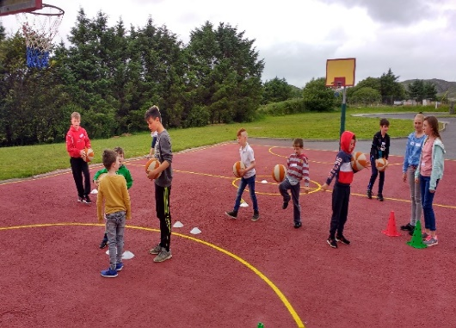
Sixth class, together with Mr. Lane, organised Sports Day this year. Each child in 6th class led a mixed team of classes to do 10 activities. Some of the activities were obstacle courses, golf, hopscotch, basketball shots and sack races. Unfortunately, the rain came for the last 2 activities, but we had great fun! We can’t wait to do this again!
Marine Harvest by Maryrose
In April, 5th and 6th classes went to town to participate in “Working it Out” in partnership with Marine Harvest. Pupils from Eyeries N.S., Urhan N.S. and Castletownbere N.S. were split into mixed teams with 2 workers from Marine Harvest to complete each task, which included skipping, ring-throw, maths bingo and basketball. The team with the highest score won, which was the blue team, who received treats and notebooks. We had great fun and really enjoyed our day!

Swimming Lessons at the Water School
After Easter, 1st to 4th classes set off to the Water School for 6 weeks of swimming lessons. We were all in groups at our own level of swimming. Some of us were learning how to do ‘froggylegs’, while others were learning to dive! While we were waiting for a group to finish swimming, we got to play in the wonderful new playground at St. Colum’s GAA grounds We can’t wait to go again next year!

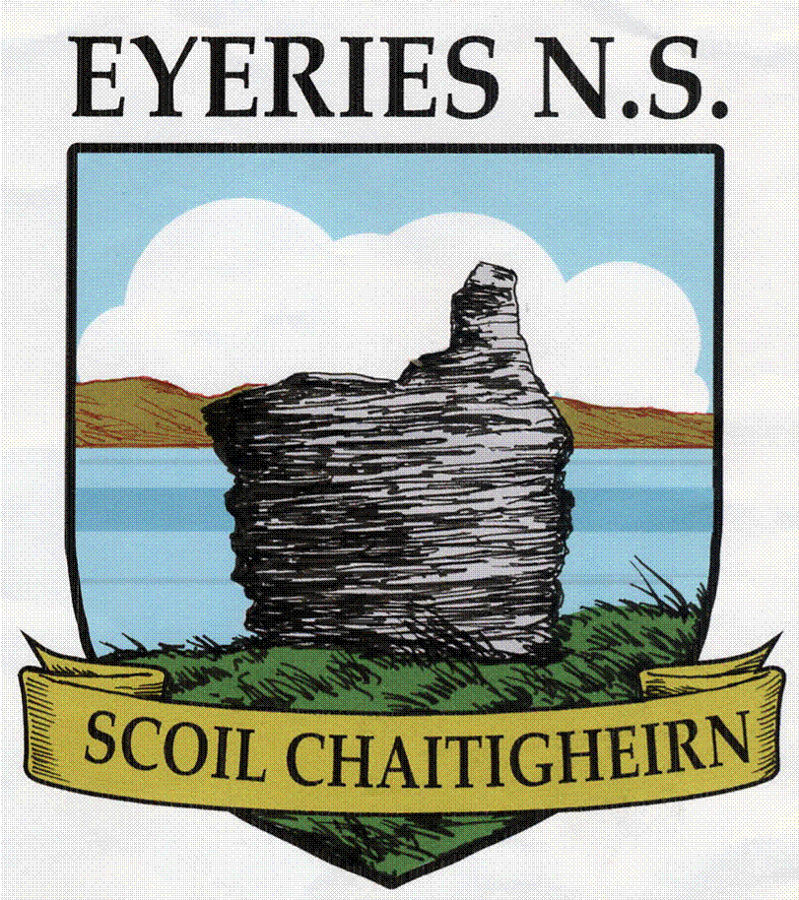
Summer
Newsletter 2018

Dear Parent(s)/Guardian(s),
We hope you enjoy our final newsletter of the current school year. As you can see the children have been very busy in a wide range of activities and they have done you and the school most proud.
Our last term was tinged with sadness with the passing of Board of Management chairman Donal Harrington Causkey. Donal served the Board with dedication and great commitment for over 12 years and was an integral part of the governance of the school. Ar dheis Dé go raibh a anam dílis.
I wish to thank the Board of Management, the Parents’ Association and all the Staff for their diligence, energy and professionalism during the year.

May the Staff and I wish you a good read and a happy and safe Summer Holiday.

Jimmy Murphy.
______________________________________________________________

Animal Roadshow by Nichola

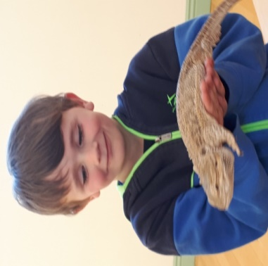

On April 20th, the Animal Roadshow came to our school to show the children a variety of different animals, including a tortoise, a bearded dragon, an owl, cornsnakes and a chinchilla! We learned lots about the animals and had great fun while doing it. Thanks to the Parents’ Association for organising and funding this great day!

Football by Cameron
We set off on June 12th at 11am to play Scoil Réalt na Mara, Tuosist. The girls played first, followed by the boys. We had 2 great games, but unfortunately lost both. Well done to Tuosist!

School Website
Please check our school website for regular updates! www.eyeriesns.com

Book Fair by Anna
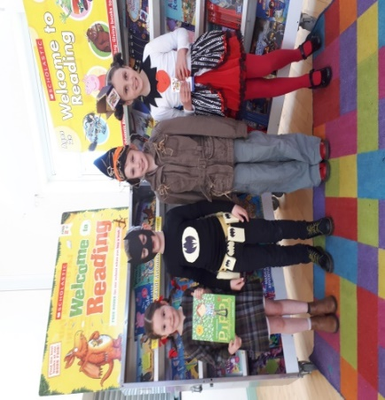
On April 23rd, Mr. Lane organized that the Scholastic Book Fair come to our school for a week. Fifth and Sixth classes ran the show and were very enterprising, selling personalised book marks as part of the Junior Entrepreneur Programme. The children got to dress as characters from their favourite books. We had a winner from each classroom, who got to choose a book as a prize.
Fire Brigade Visit by Nina
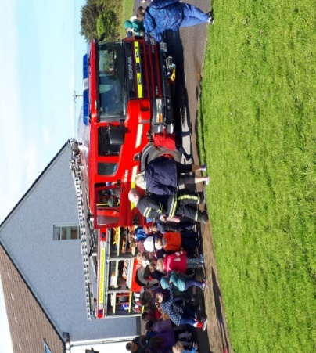
On Wednesday May 2nd, the local Fire Brigade came to visit the school. The firemen showed us how to use a fire extinguisher and a fire blanket. Most importantly, we were shown how to check our fire alarms! They heated a pot of oil and showed us what happens when a tiny bit of water was poured on it. We got to check-out the fire truck, examine hoses and try on helmets. It was a great day!
Incredible Edibles
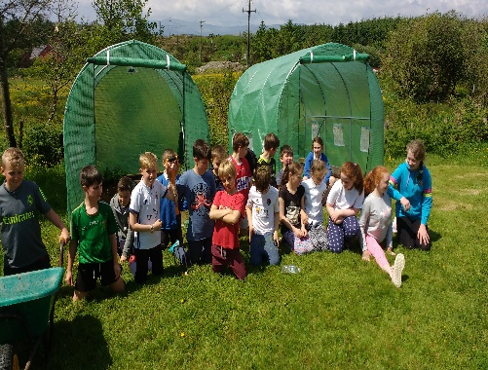
The older classes have been incredibly busy sowing and growing a variety of vegetables in our new green-houses. The heat in the green houses boosts the growth of the vegetables, which include potatoes, onions and lettuce. The lettuces have gotten really big and we can’t wait to put them in our sandwiches!
School Wall Murals by Aisling
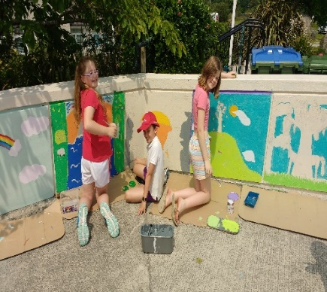
At the end of May, 1st to 6th classes started on the walls at the front of the school, with the help of Mrs. Fran Murphy. She gave us lots of useful tips with our sketches. Benedict Coleman helped us with painting the walls. We learned about mixing colours and creating different tones of colour. Infants painted the walls of their yard. We had great fun!
Playground Games
We got fantastic new games painted on the Infant and First & Second class yards! The basketball court in the senior yard was also done! Míle buíochas to the Parents’ Association and the Eyeries Family Festival for funding this. We are having a wonderful time with the new games!

Crazy Hair Day by Maeve
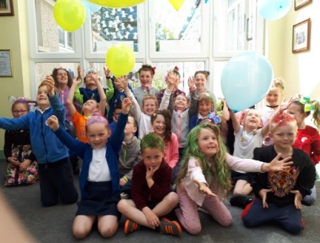

On May 25th, we had Crazy Hair Day to raise funds for Crumlin’s Children’s Hospital. We all donated €2 and raised €200! The hair styles were fantastic and even the teachers participated! Mr. Murphy looked very glamourous as a blonde and Mr. Lane was very glittery!
Cork City Sports
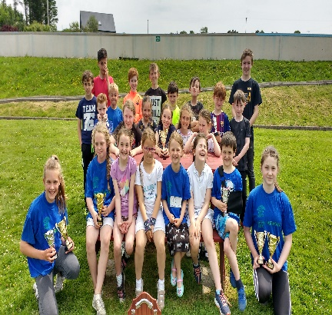

June 1st brought us a sunny day in CIT for Cork City Sports. The girls ran first and brought home 3 trophies. They also came first in the relay!
The boys ran later in the day and also brought home 3 trophies. Well done to everyone!
Sixth Class Graduation by Ailbhe
Fr. Danny celebrated mass for 6th class on June 11th at school. All the school were there and many parents and grandparents came too. Mr. Lane and Mr. Murphy spoke about us, praising us for all the work we did around the school and presented us with certificates. It was lovely to have everyone together one last time!

Safety Talk with Garda Hegarty by Mark
Garda Hegarty came to visit all of us on the 6th of June. He spoke to us about safety – water safety, cyber-bullying, dangers on the farm (e.g. slurry pits), heights, and stranger danger. He taught us how to deal with strangers and how to get away by shouting and drawing attention to ourselves. Finally, he wished us all happy and safe Summer Holidays!

Junior Entrepreneur Programme by Timothy
5th and 6th classes worked on this from February to May. Colman O’ Sullivan came to speak to us first. We then put all our ideas together and voted eventually to make personalised bookmarks, which we would sell at the Book Fair. Orders were taken from the children and they were made to order. We sold 84 bookmarks and each made a profit of €7!

Biodiversity Walk to Bofficle Woods by Alanna
Children from 3rd to 6th classes went to Bofficle Woods on a Biodiversity Walk with Eoghan Daltun on May 11th. In the clearings, we named all the wild flowers and trees we knew and learned even more. In groups in another clearing, we collected leaf matter and insects in tubs. One group even found a frog! All the critters were returned to their habitats unharmed! We had a great day and can’t wait to return next year!

