Science Day with Mr. D by Liam
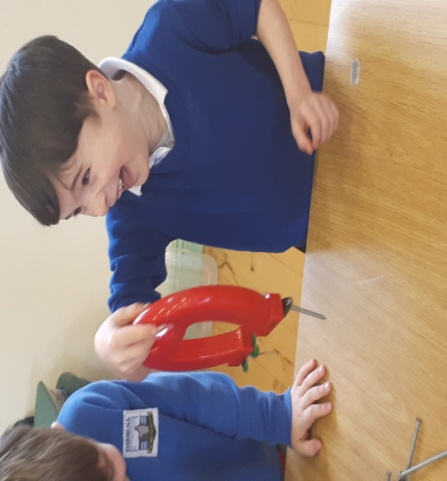

Science Day was great! Mr D. had a number of different stations such as how a bike works, cool sounds with glass, magnets, magnifying glass, work tools and colour mixing. Each class had their turn in the hall at the stations. Mr. D was very patient with us and let us explore each station, where we worked with the materials on our own. We hope he returns again!

Music with Peggy by Daniel
Peggy continues to come to us every Thursday, teaching us tin whistle. At the moment, fifth and sixth classes are learning to play “Whiskey in the Jar” and “Bridge over Troubled Water”. Peggy runs classes after school on Thursdays where she teaches piano, accordion, fiddle and guitar. Our school band are fantastic as they work really hard with Peggy.

Football Skills with Kieran by Cian
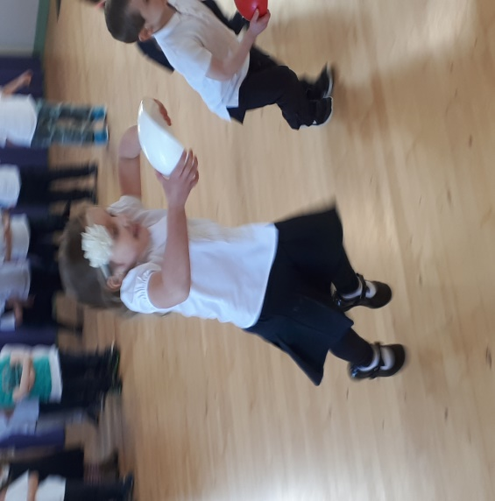

Kieran came to us for 6 weeks and worked with all the classes. Sometimes we practised in the hall and other times we were in the yard or on the grass. Some of the skills we learned were hopping, jumping, catching and scoring. We played lots of games when we were learning the skills which made it lots of fun. Thank you Kieran for all your hard work.

Sciath na Scol Preparations by Oisín
Sciath na Scol 2018 preparations are well under way. About 20 boys and 20 girls go to the pitch every day with Mr. Murphy to train. Turnout has been great and we hope to bring home some trophies when we play matches after Easter. Until then, I hope we have as much fun as we always have.

School Tours
Information on school tours will be provided after Easter.

Easter
Newsletter

Dear Parent(s)/Guardian(s),
Welcome to the Easter (first) edition of our school newsletter. This has been a very busy year so far for all involved at Scoil Chaitigheirn. As you will see throughout this newsletter we have had a lot of fun events throughout the year and more to come!

As we come to the end of our second term, I would like to thank all those involved with the Parents’ Association. Their hard work and efforts are very much appreciated by all here in Scoil Chaitigheirn.

I would also like to acknowledge our excellent staff and my thanks to all the children of Scoil Chaitigheirn for their on-going work, particularly sixth class who have a variety of chores they complete daily and help the school run more smoothly.

On behalf of the school Board of Management, staff and myself, I would like to wish you all a very happy and safe Easter Holiday.

Is mise le meas,
Seamus Ó Murchú
______________________________________________________
Confirmation by Gráinne
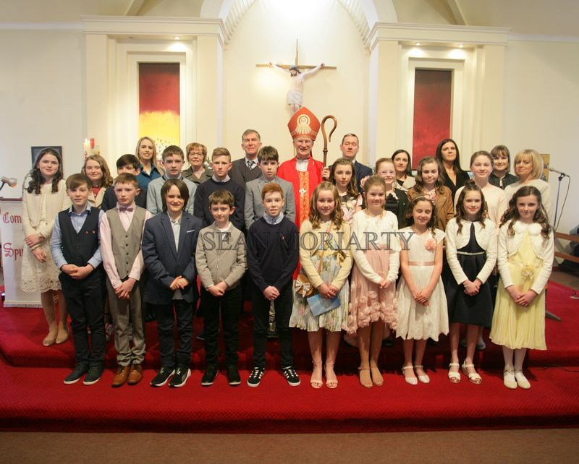

On Tuesday, February 27th, 20 children from fifth and sixth classes made their confirmation, together with 5 children from Urhan N.S.. Bishop Ray Brown confirmed us and was helped by Fr. Broderick and other priests from nearby parishes. Mr. Lane prepared us really well for the ceremony and there were no nerves on the day! Peggy Healy and Ms. Crowley helped with the choir, who were wonderful. We all looked lovely and really enjoyed our day.

Irish Dancing with Hannah by Amanda
Junior Infants to Sixth Class started Irish Dancing on January 26th for 6 weeks. It was great fun! We had a fun warm-up each week and learned a dance. We all performed our dances on Grandparents’ Day and got a big round of applause! Thank you Hannah!

Grandparents’ Day by Emily
On Friday March 9th, we celebrated Grandparents’ Day at school. Grandparents, Grandpals and parents came to the school at 1pm. Mr. Murphy welcomed everyone and Fr. Danny said a prayer. Each class performed their dance brilliantly. When we were finished, tea and biscuits were served by the Parents’ Association and we got a chance to chat to everyone. It was a wonderful day.
Snow Days by Sam
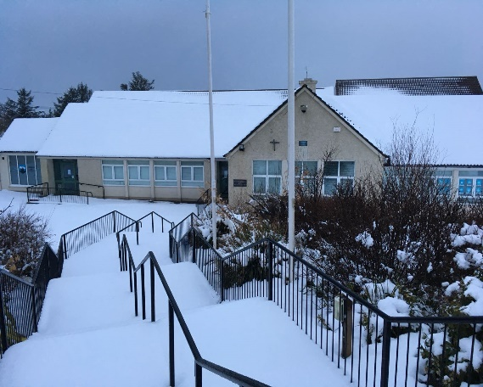
While we had no school due to the weather on March 1st and 2nd, we kids wrapped-up well in big coats, hats, scarves and gloves and braved the cold. We had 6-8 inches of snow and were very creative! We made snowmen, snowwomen, igloos, snowcastles and anything you could possibly think of. Others climbed hills with anything they could find to slide down in the snow. We were very disappointed when it thawed!

Bulb Planting
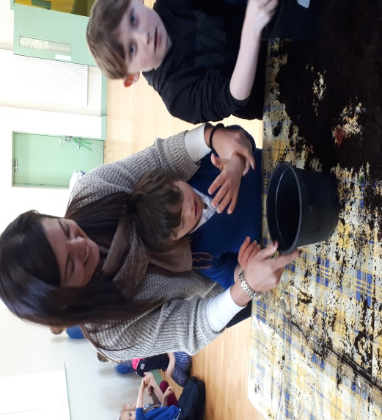

We had great fun planting bulbs in December, thanks to the Parents’ Association and Connie. We made a big mess, but the helpers from 6th class were great at cleaning up! The bulbs are now growing and we check every day to see if any have started to bud or have bloomed. There is great excitement when another one appears!
School Website
The school website is being updated regularly and we would love it if you checked us out on
www.eyeriesns.com

Communion Preparation
There is great excitement in 2nd class as preparations for Communion are well underway with Ms. Crowley. The children had First Confession at the Church of the Resurrection, Ardgroom on Wednesday, March 20th. First Communion will be celebrated at St. Kentigern’s Church, Eyeries on May 12th at 11am.

Communion Preparation
There is great excitement in 2nd class as preparations for Communion are well underway with Ms. Crowley. The children had First Confession at the Church of the Resurrection, Ardgroom on Wednesday, March 20th. First Communion will be celebrated at St. Kentigern’s Church, Eyeries on May 12th at 11am.
Green Day
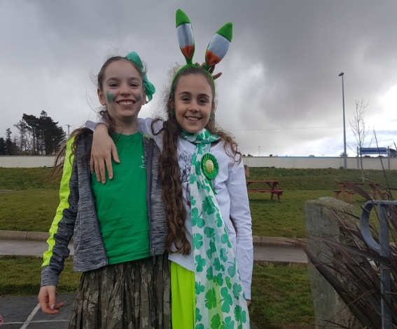
We celebrated Green Day on March 16th and great fun was had by all! We all dressed in green to celebrate Lá ‘le Pádraig. Mr. Lane, together with sixth class organised “Tráth na gCeist” for the whole school. They created the rounds of questions, printed them, organised teams, corrected the questions and announced the winning team. Bhíomar an-bhródúil astu uilig leis an líon oibre a dheineadh an lá úd. Míle buíochas dóibh ar fad.

Food Dudes
Food Dudes has been a very successful initiative in the school this year. Lots more fruit and vegetable are appearing in the lunch boxes and the children are continuing to “Feed the Force!” Food Dudes will return for one week, April 9th to 12th, when the children will once more be treated to a portion of fruit and vegetables daily.

Sensory Garden
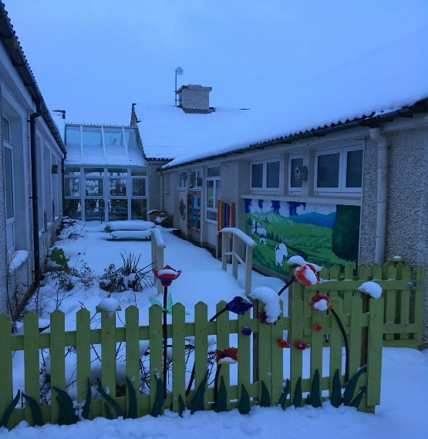
We had the official opening of our beautiful Sensory Garden earlier in the year. Since then, we have had many visitors to our garden. Teachers from other schools have asked to come to see it, as it was recommended by Department of Education officials as a wonderful example. It has also gotten a write-up in the Southern Star! Míle buíochas to Ms. O’ Shea and Ms. Harrington for their work in making this amazing resource happen and their continued work in keeping it looking wonderfully well. See it here looking magical in the snow!
Swimming Lessons
Swimming lessons for 1st, 2nd 3rd and 4th classes will begin again on Thursdays, after Easter at The Water School in Kealkil. Swimming dates to note are April 12th, 19th, 26th, May 3rd, 17th& 24th. Please note there is no swimming on May 10th. Swimwear, towel and goggles are essential. Swimhats are not required. We expect the cost to be €40 approximately.

